Lab 5: Speed of Sound

Kenneth Zhuang

February 16, 2017

TA: Janaki Sheth

Lab Section 8

Lab Partners: Frank Chen, Jayendra Jog

Introduction

The main objective of this experiment was to measure both the speed of sound and the speed of light. Comparison between the theoretical values and the experimental values will then be made. For the measurement of the speed of sound, two phenomena will be explored: namely traveling sound waves and standing sound waves. For the traveling sound waves, a microphone, a speaker, and an oscilloscope setup will be used. The phase will be varied by a factor of $π$ and $2π$ to measure the wavelength and also to acquire the phase velocity. This will be undertaken for 5 different frequencies to show that the speed of sound does not vary with frequency. For the standing sound waves, a reflector will be used to show the amplitude difference between node spacings to measure the wavelength. These measurements can then be manipulated to get the speed of sound.

Experimental Results

For the traveling wave section, a microphone, a speaker, and an oscilloscope setup was used to measure the speed of sound by measuring the wavelength at 5 different frequencies. The wavelength was measured by varying the distance between the microphone and the speaker by $π$ and 2 $π$ as shown in the oscilloscope. A ruler was used to measure the distance that the microphone moved.

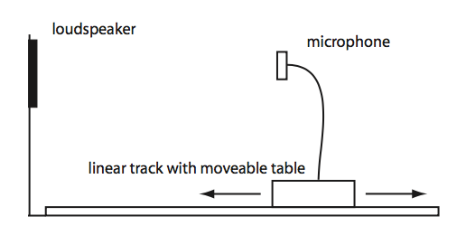

Figure 1: Microphone and Speaker setup used for the traveling wave experiment.

The microphone and speaker were placed in front of each other and driven at 5 different frequencies. A ruler was placed beside the microphone and the distance was varied by $π$ across different increments measured by the oscilloscope.

Figure 2: A graph of angular frequency as a function of the wavevector.

The angular frequency was acquired by taking the driven frequencies and multiplying them by a factor of 2 $π$. The wavevector was calculated by dividing 2 $π$ by the measured wavelengths. 0 was set as the intercept of the graph. The form of the function is a linear one, and the slope can be calculated by doing a linear regression analysis on the graph. The slope in this case will be the phase velocity. The slope is given by the value: $381 ±20\frac{m}{s}.$

For the standing wave section, a shield was used to reflect the sound waves from the speaker to cause either constructive or destructive interference. Continuous voltage measurements were taken by the MyDAQ as the shield was slowly moved backwards, modeling a sine wave across five to six oscillations. The frequency was set at a value of 5 kHz. To convert the voltage measurements into usable data, calibration was done first. To do this, voltage measurements were taken for the shield as it moved at set distances. The scaling factor can then be acquired from this data.

Figure 3: A graph of the calibration data for the standing wave section.

The slope in the graph refers to the conversion factor between voltage and distance, which has a value of (-1.03 $±$ 0.01). This value multiplied by the voltage will yield distance.

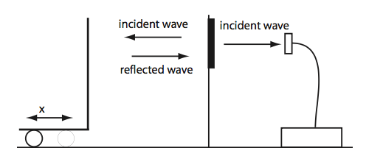

Figure 4: Setup of the Standing Wave Section.

The shield was moved away from the microphone slowly as voltage measurements were taken for both the position voltage and the microphone signal.

Figure 5: The graph of the microphone voltage vs. position.

The distance was taken by multiplying the distance voltages with the conversion factor taken from the slope in Figure 3.

|  |  |
| --- | --- |
| Wavelength | Uncertainty |
| 5.80E-02 | 0.002 |
| 7.20E-02 | 0.002 |
| 7.00E-02 | 0.002 |
| 6.20E-02 | 0.002 |
| 7.60E-02 | 0.002 |

Table 1: Measurement of the Wavelength in Figure 5.

The measurements of the wavelength were acquired by taking the peak-to-peak distances across 5 oscillations and multiplying the values by a factor of 2. The uncertainty was taken from eyeballing the graph.

Analysis

The results of the linear regression on the traveling wave section of the experiment yielded a value of $381 ±20 m/s$ for the phase velocity. Compared to the theoretical value of the speed of sound, 343 m/s, the theoretical value is not within the range of the uncertainties of the experimentally determined value. The error in this case could be a systematic error in the experiment. For example, when 0 is not used as a data point for the intercept, and only the measured values from the lab are used for the linear regression analysis, a value of $366 ±34 m/s$ for the phase velocity is acquired. This value is within the range of the theoretically correct value. As can be seen, the acquired values from the lab do not have 0 as an intercept, and thus differs by a scaling constant. The human eye could also have contributed to the errors, as it was used to look at the oscilloscope and keep track of $π$ and 2 $π$ phase shifts. As there were lots of phase shifts measured, multiple errors result. In addition, errors could have been in the driving of the frequencies, which might not have been really the frequencies being shown in the oscilloscope. The measurement of the distance also carries with it an error of 0.2 cm for each data measurement, and as such could have contributed to the overall error in the slope measurement.

For the standing wave section, the average wavelength was acquired by taking the mean of the values shown in Table 1. It was calculated to have a value of $(0.068 ±0.007)$ m. The uncertainty was taken by taking the standard deviation to the mean. To calculate the speed of sound, the frequency of 5 kHz is multiplied with the mean wavelength, yielding a value of $340 ±35 m/s.$ The uncertainty was calculated using the formula:

$σ_{\overline{F}}=\sqrt{{\left(\frac{∂f}{∂λ}σ_{\overline{λ}}\right)}^{2}+{\left(\frac{∂f}{∂freq}σ_{\overline{freq}}\right)}^{2}}$. Compared to the theoretical value of 343 m/s, the experimental value is extremely close to it and the uncertainty is well within the range.

Comparing the measurements of the speed of sound from the traveling wave method and the standing wave method, it is clear that the standing wave method is more accurate, as it is much closer to the theoretically accepted value. The resolution of the traveling wave was better however as its uncertainty range was much lower. The difference in the accuracy between these two methods could be due to the fact that in the traveling wave method, there was more data to work with, and as such the error variables will be much more. Human error is also more prevalent in the traveling wave method, as the human eye is needed to look at the oscilloscope and decide whether $π$ or 2 $π$ phase differences have been crossed.

Conclusion

The results of the experiment clearly show that the objectives were met. Values were measured for the speed of sound using two different methods, and reasonable values were gotten with respect to the theoretical speed of sound. While the measurement for the traveling wave experiment did not fall within the theoretical value, the standing wave measurement did. To account for the errors in the traveling wave experiment, better fully functional equipment could have been used. Also, instead of using the eye test to observe phase shifts, the cursors of the oscilloscope could have been used to yield better more accurate results.